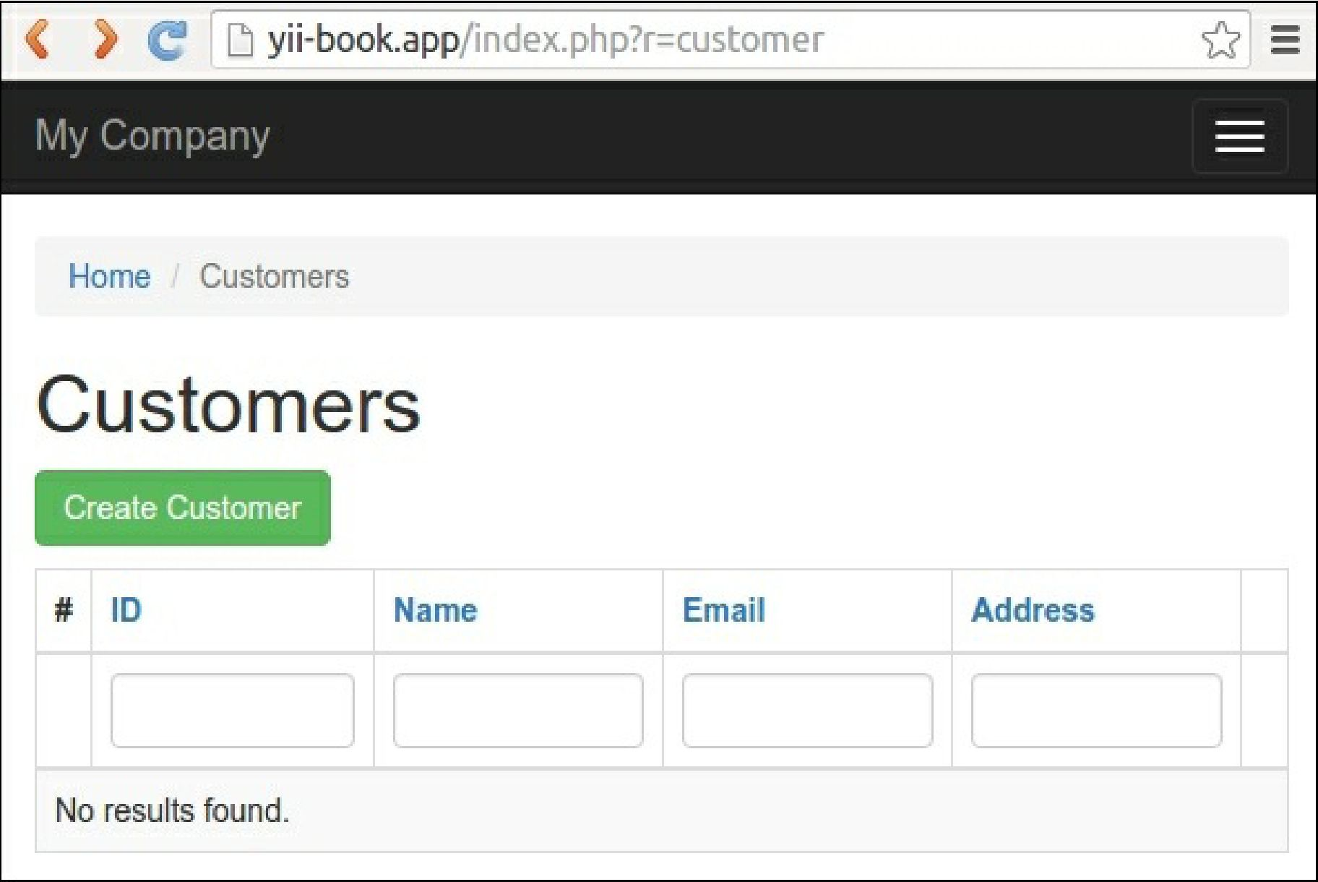

You will see a data grid showing the customers in the database table. Try to create a new item. You may sort the grid or filter it by entering filter conditions in the column headers.

**Working with CLI**

Gii also provides a console controller for code generation.

1. Check that your console configuration contains the Gii module settings:

return [

// ...

'modules' => [

'gii' => 'yii\gii\Module',

],

// ...

];

2. Run any shell command for help:

php yii help gii php yii help gii/model

3. Type the following command to start the model generation process: